Bluetooth Pulse Oximeter

Brief Overview: a pulse oximeter having Bluetooth data transfer capabilities.

Sensor used: MAX30100 pulse oximeter

Display: I2C 0.96” OLED screen

Microcontroller used: Arduino nano

Bluetooth Module: HC-05 Bluetooth module

PCB: single layer, designed in CEDT lab

Misc. components: 10K resistors, 0.1uF ceramic capacitor, 10uF cylindrical capacitor, M02

Schematic:

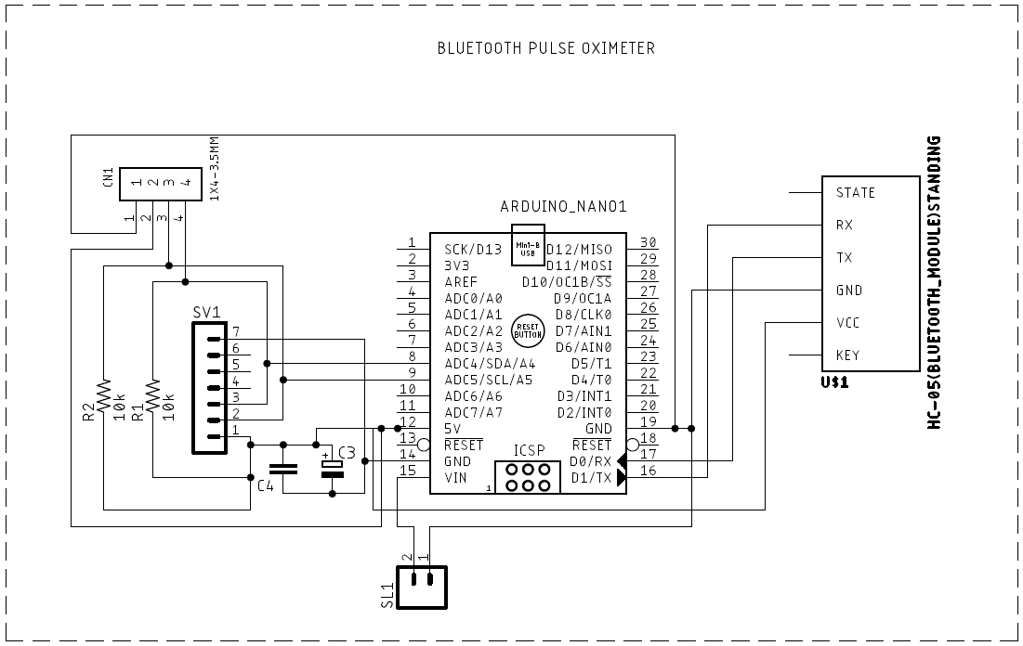

Brief description of the schematic:

The connections of all the above-mentioned components are as shown in the schematic.

Elaboration is however required for the exact use of the misc. components mentioned above (resistors, capacitors and the M02).

The two 10K capacitors are the pull-up capacitors (without which we found out that the sensor wouldn’t work in a desired way)

What are pull-up resistors?

In electronic [logic circuits](https://en.wikipedia.org/wiki/Logic_circuit), a **pull-up resistor** or **pull-down resistor** is a [resistor](https://en.wikipedia.org/wiki/Resistor) used to ensure a known state for a signal. It is typically used in combination with components such as [switches](https://en.wikipedia.org/wiki/Switch) and [transistors](https://en.wikipedia.org/wiki/Transistor), which physically interrupt the connection of subsequent components to [ground](https://en.wikipedia.org/wiki/Ground_(electricity)) or to [VCC](https://en.wikipedia.org/wiki/IC_power-supply_pin). Closing the switch creates a direct connection to ground or VCC, but when the switch is open, the rest of the circuit would be left floating (i.e., it would have an indeterminate voltage).

Use of capacitors: there basic function is to reduce the high frequency and low frequency noise (filtering purposes).

The M02 is placed for the external power source to drive the circuit (which as of now is not decided, most probably a 9v battery).

PCB Layout using Eagle

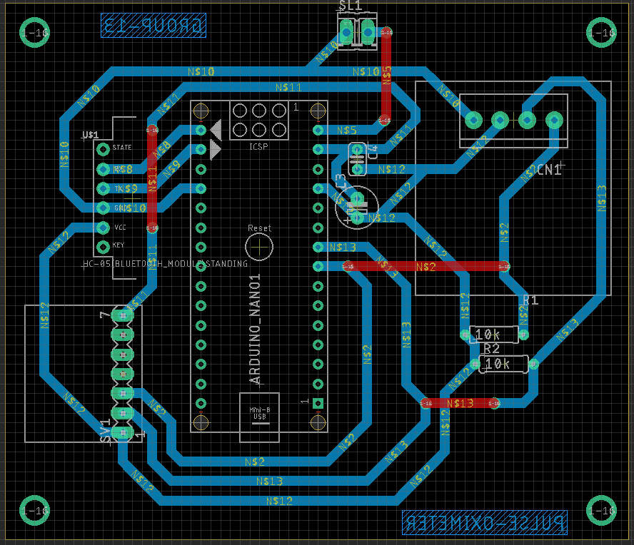

Actual images of the fabricated PCB:

